Janak Rathod

Python  DATA ANALYSIS

CHICAGO CRIME ANALYSIS 2017

TABLE OF CONTENTS

|  |  |
| --- | --- |
| Sr. No | Description |
| 1 | Overall Crime Analysis |
| 2 | Theft Analysis |
| 3 | Criminal Damage |
| 4 | Deceptive Practice |
| 5 | Narcotics |
| 6 | Prostitution |
| 7 | Homicide |
| 8 | Other Offense |

**OVERALL CRIME ANALYSIS**

1. Types of crime

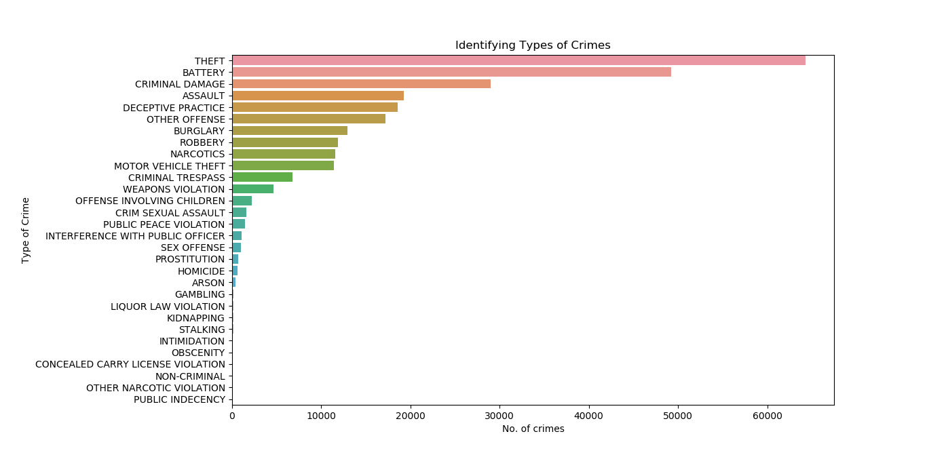

* It is visible that Theft cases account for maximum amount of crimes in the city.
* Battery, criminal damage and assault end up occupying second, third and fourth place respectively.
* Reduction in theft cases can drastically decrease the crime count in the city.

1. Blocks with maximum number of crimes

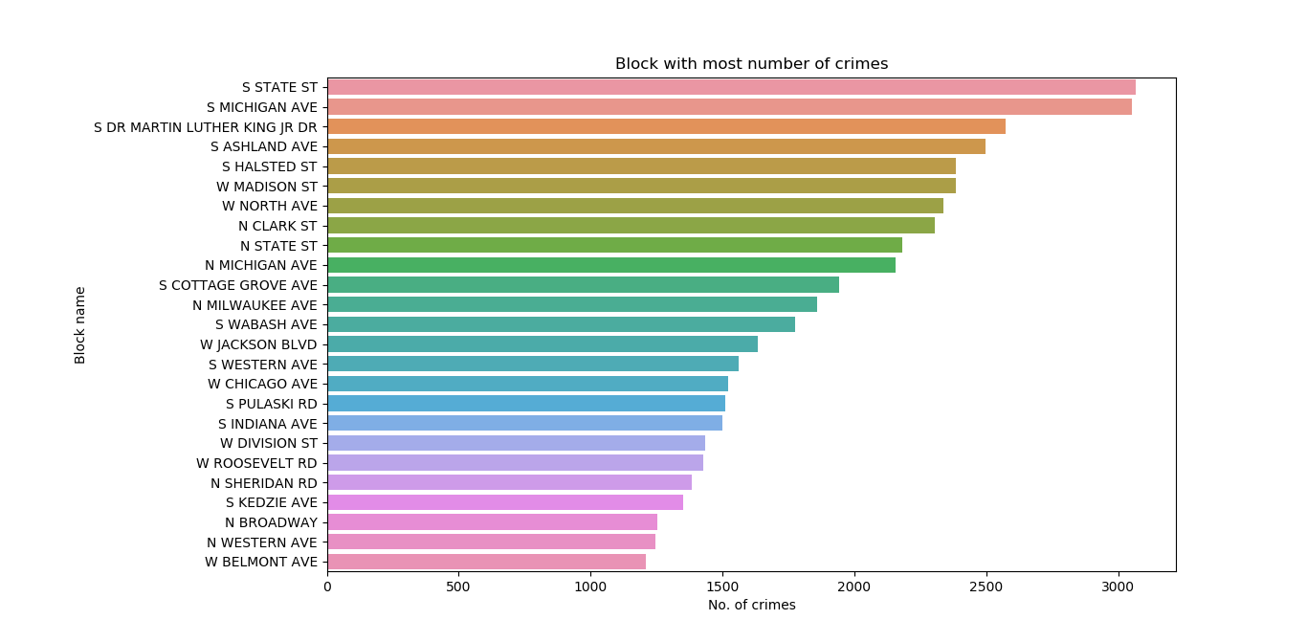

* It can be noted that South State Street is most notorious for crimes followed by South Michigan Avenue, South Dr Martin Luther King Street and South Ashland Eve.
* Increasing patrolling by law enforcement can reduce the rate of crime.
* Public awareness can also help in reducing criminal activities.

1. Crime in days of the week.

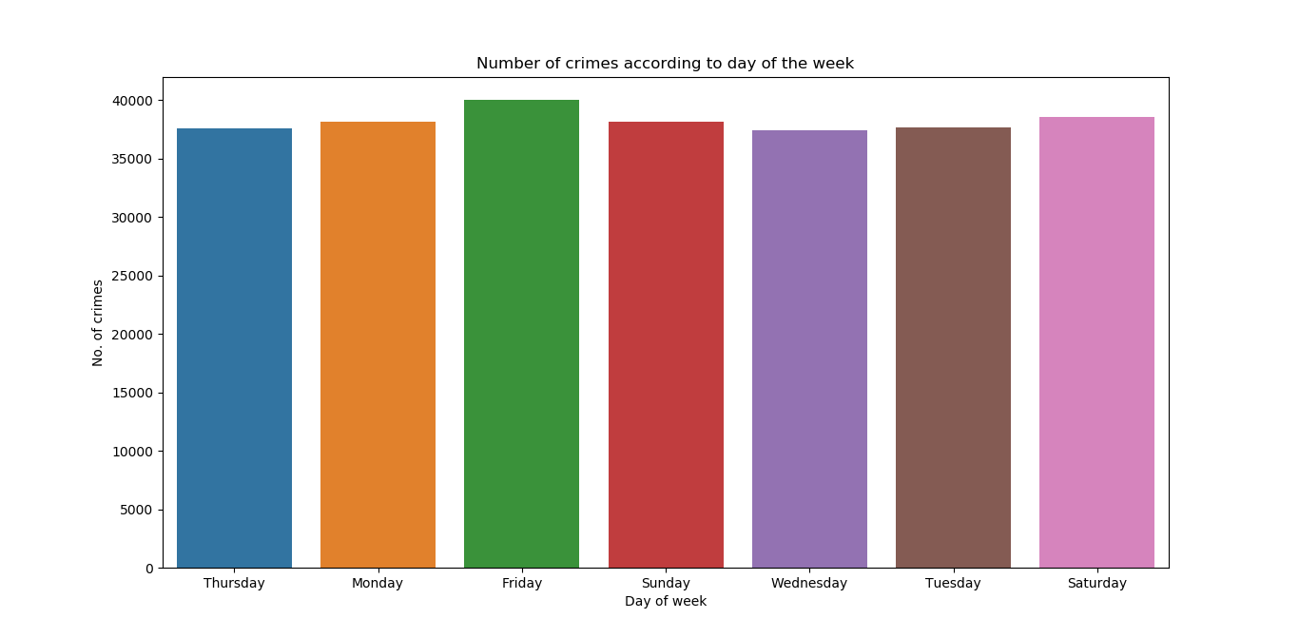

* It can be identified that almost all the days have equal amount of criminal activities.
* It was my perception that weekends could have been the days with more crimes, such as, narcotics, burglary and prostitution.

1. Crimes with respect to time of the day

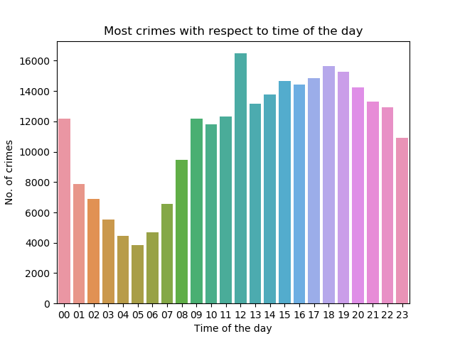

* Early morning records the least amount of crimes.
* According to the data mentioned later, most of the criminal activities happen on the street. The crimes do not take place on such hours as no people are there on the location such as the street.
* Further we will observe the crimes taking place at different times of the day.

**THEFT ANALYSIS**

* It is observed that theft cases amount to most number of crimes in the city.
* In this section we will explore more about the locations, blocks with high density of such crimes and the number of arrests.
* Furthermore, reduction in theft cases will reduce the overall crime count in the city.
* Out of almost 2,67,440 crime cases, theft cases amount to more than 60,000 cases.

**THEFT ANALYSIS**

1. Theft Description

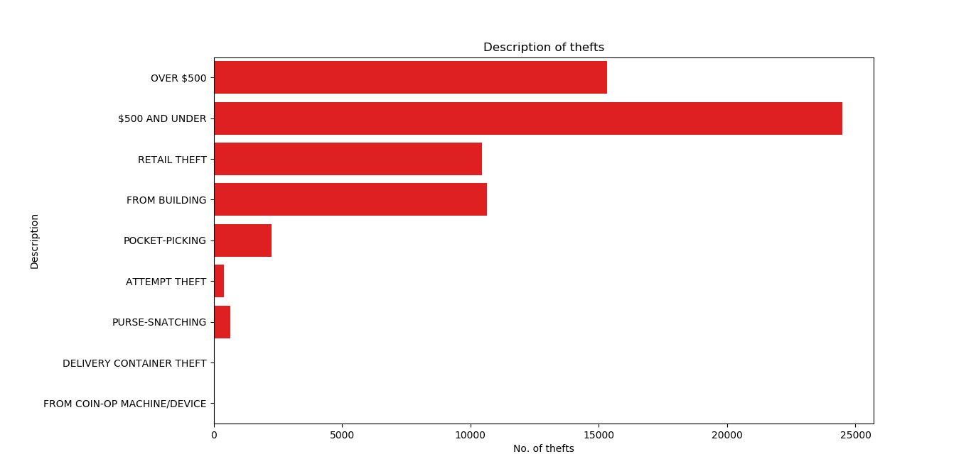

* Theft in the form of cash has been the most in cases.
* Under $500 of cash tops the list of type of cash thefts followed by cash theft of more than $500.

1. Block with highest theft cases.

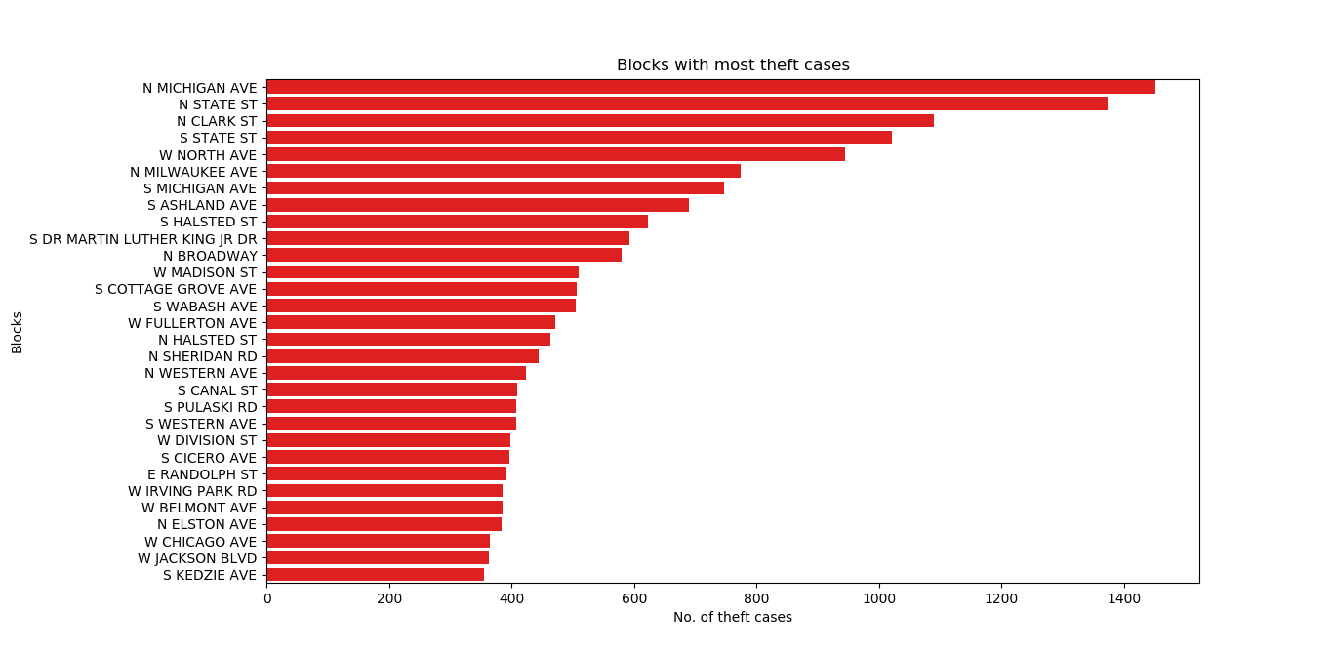

* North Michigan Avenue tops the list of blocks with most theft cases.
* North State Street, North Clarke Street follow on.
* Increased patrolling on these blocks can drastically reduce the theft cases in these blocks.

1. Location with maximum thefts.

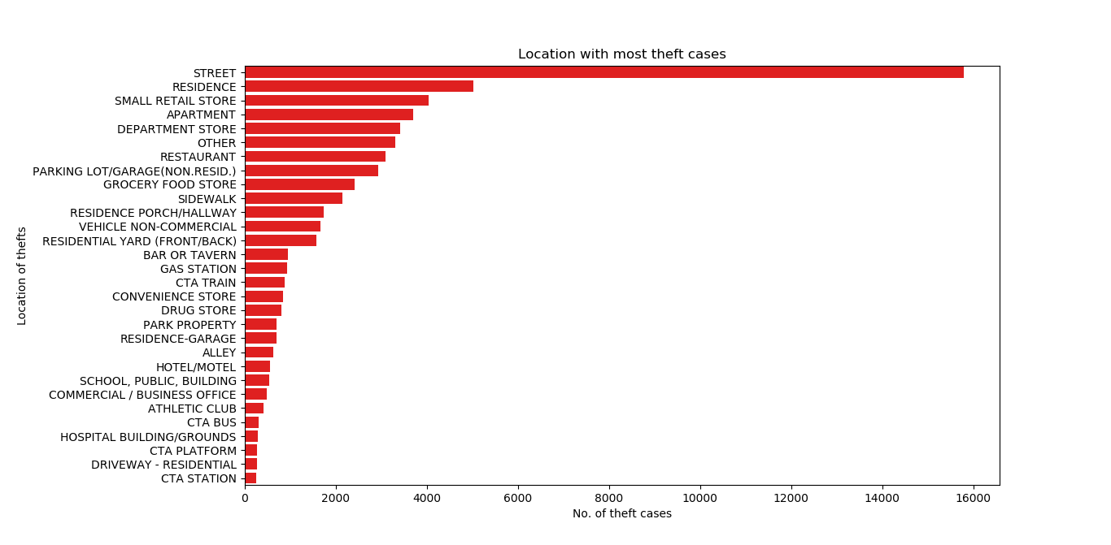

* It can be observed that theft cases are most observed on the street.
* Maybe there are some isolated places on the street where it is possible to steal some cash from people.
* As observed earlier, the streets of North Michigan Avenue record the highest number of thefts.
* CCTV cameras can help identify the culprits.
* Public should be made aware of the crime prone blocks to take care of their belongings.
* Increased patrolling and awareness are the best solutions.

1. Theft Arrests.

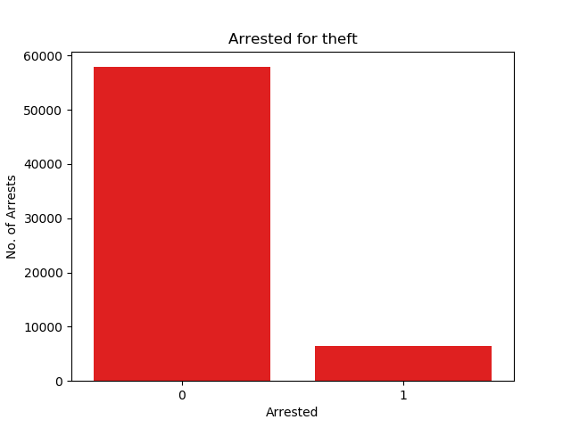

* Less than 10,000 out of more than 60,000 theft cases have led to arrests.
* The reason can be lack of proof against the accused or the suspect may not have been identified committing crime.
* Number of arrests need to increase in order to put a check in the theft menace.

**CRIMINAL DAMAGE ANALYSIS**

1. Criminal Damage Description.

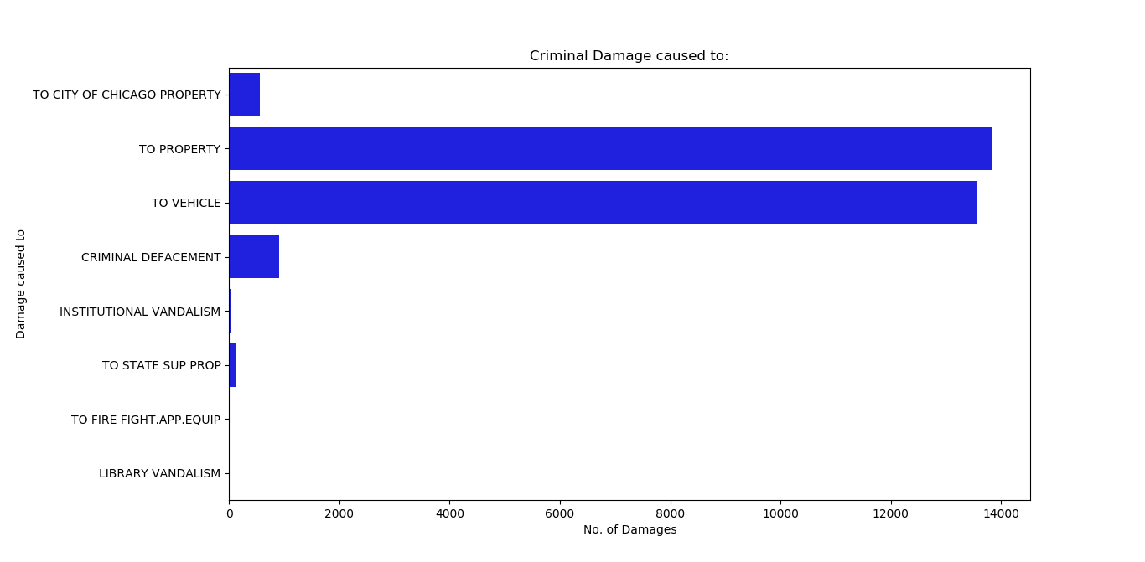

* Criminal damage to property and to vehicle record the highest number of cases.
* Criminal damage to vehicles can be caused due to road rage or due to accidents.
* Damage to property can be caused due to riots or brawls.

1. Block with most criminal damage incidents.

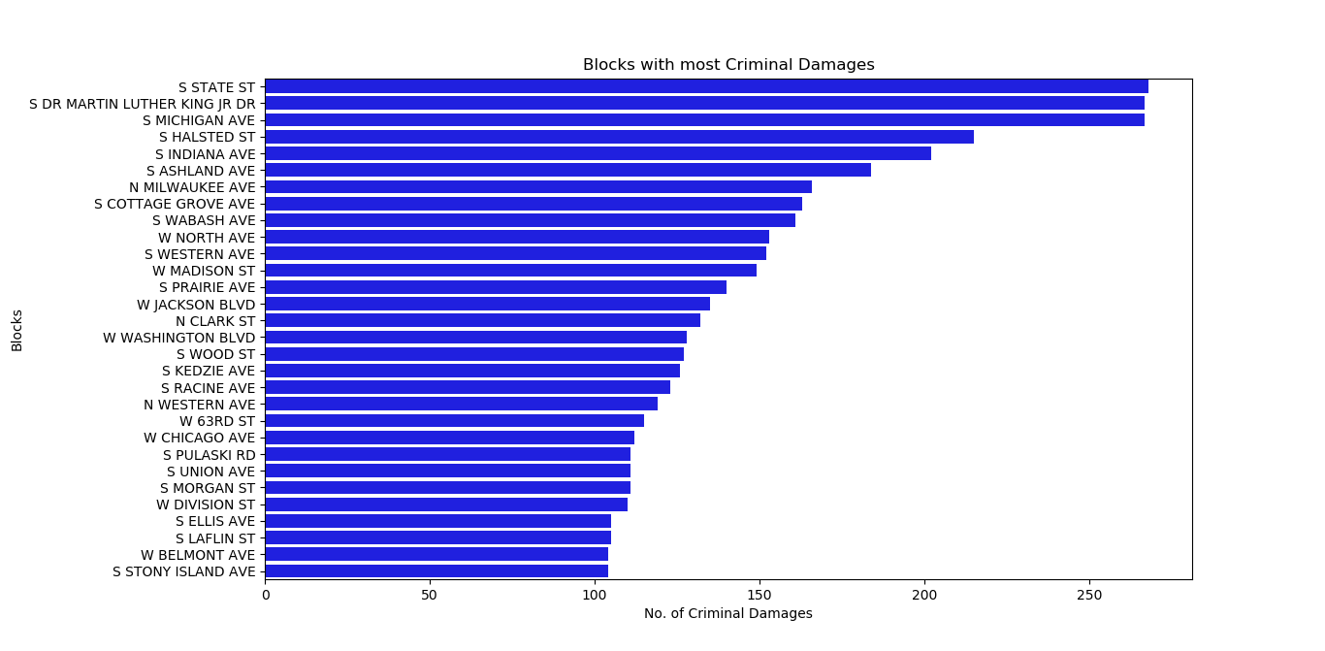

* South State street record the most cases of criminal damages.
* South Dr Martin Luther King JR Street and South Michigan Avenue follow.

1. Location of criminal damage:

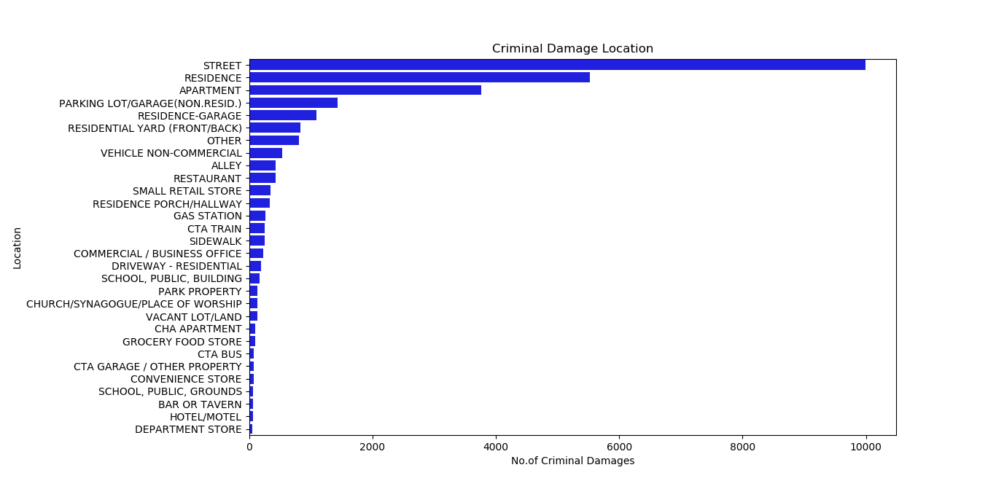

* Street remains the top location for most of the crimes and criminal damage is no different on the street.
* Almost 10,000 cases of criminal damage have occurred on the street.
* Residence comes at the second spot, which drives us to the conclusion that property damage is the cause of residents popping up on this list.
* Family feud can be the case for such damages at residences.

1. Arrests in case of Criminal Damage:

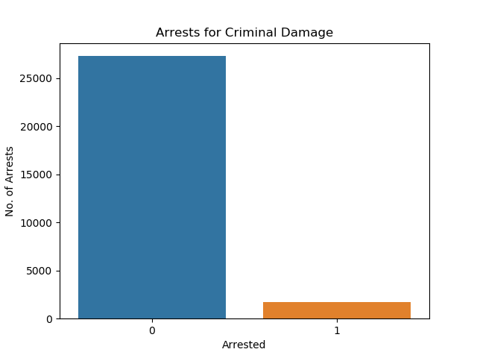

* Similar to thefts, arrests do not match the number of criminal damage cases occurring.

**DECEPTIVE PRACTICE ANALYSIS**

1. Types of Deceptive Practices:

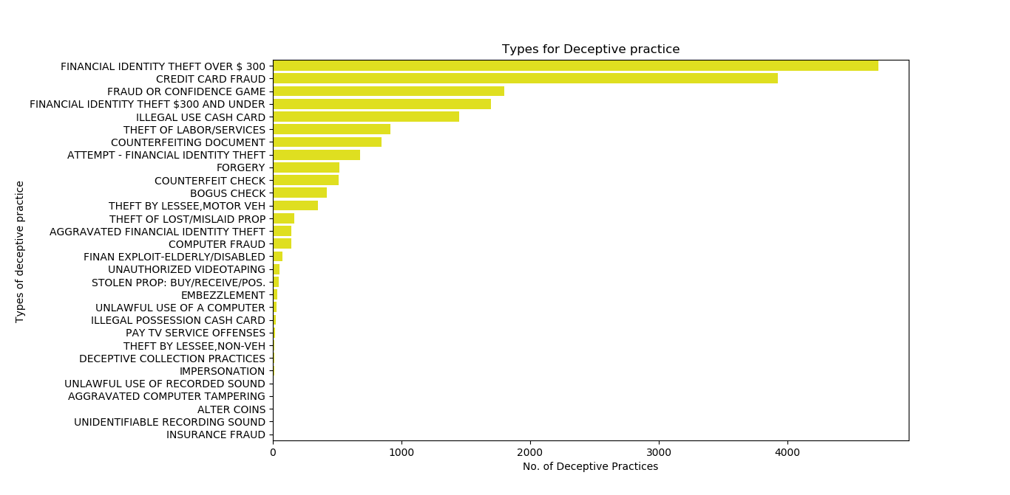

* Financial identity theft and credit card fraud record the highest number of such crimes.
* The primary reason for this crime are careless attitude of people while disclosing personal details.
* Making personal details available to public can surely cause identity theft which incur losses.
* Credit card thefts may be the reasons of card cloning or phishing.
* Awareness among the people is the only solution to stop such crimes from happening.

1. Arrests for Deceptive Practices:

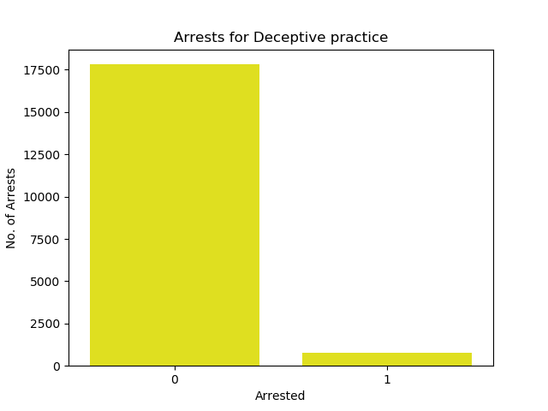

* Less than 1,000 arrests have been made in case of crime related to deceptive practices.
* The reason for such crimes is the inability of law enforcement to track or identify the suspects.
* This is because such crimes take place from places which are far away from the victim’s location.’
* As a result, it becomes difficult for law enforcement to being the criminal to justice due to various legal formalities involved in arresting the suspect.

**NARCOTICS**

1. Types of Narcotics cases:

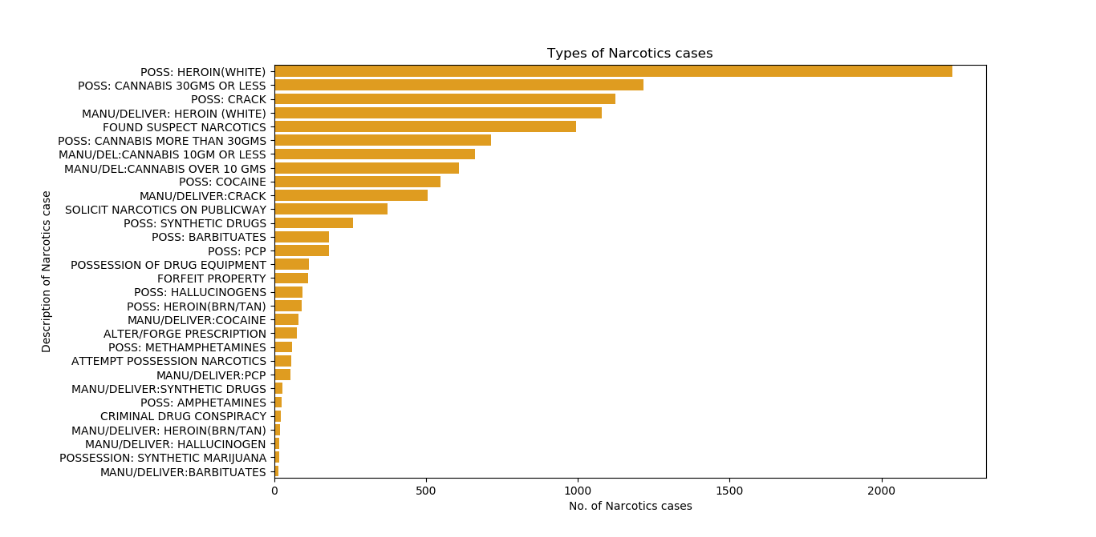

* Possession of Heroin tops the list.
* Possession of cannabis and crack are also a part of this list.
* Heroin, cannabis and crack all are party drugs.
* Hence, these drugs top the list of narcotic related offences.

1. Blocks with high cases of Narcotics:’

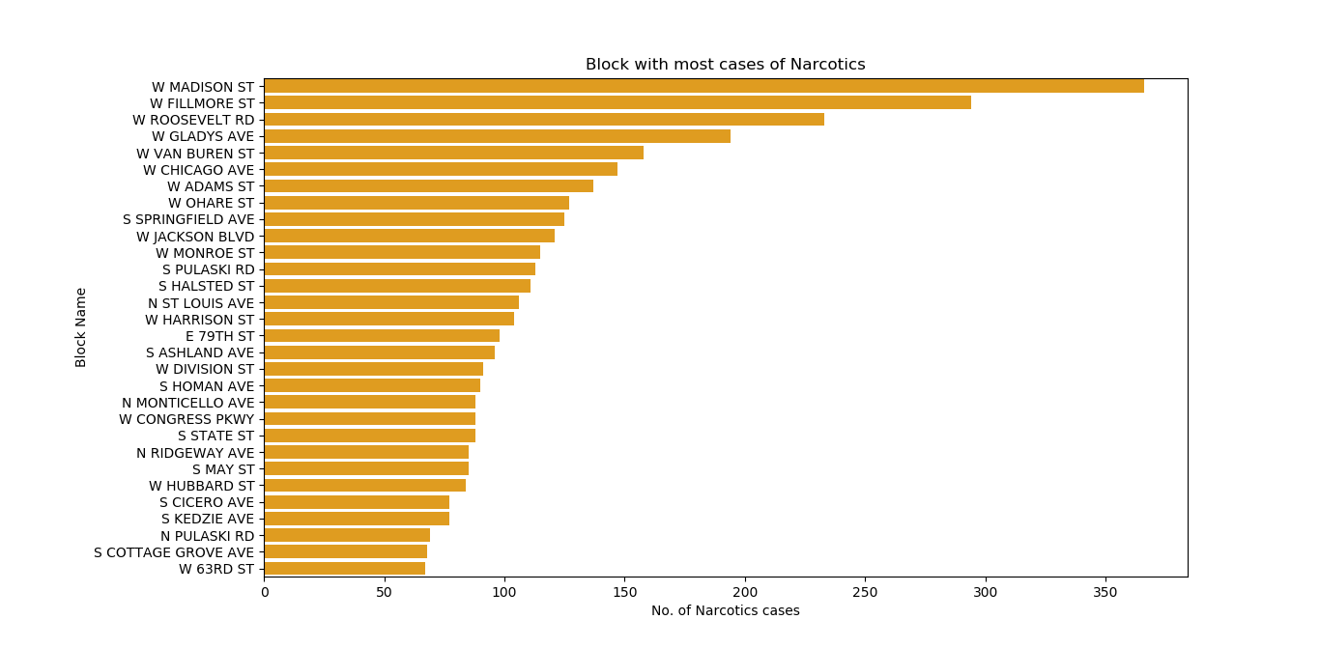

* West Madison Street tops the list of blocks with cases of such crimes.
* West Fillmore street comes a distant second.

1. Location with high narcotics related cases:

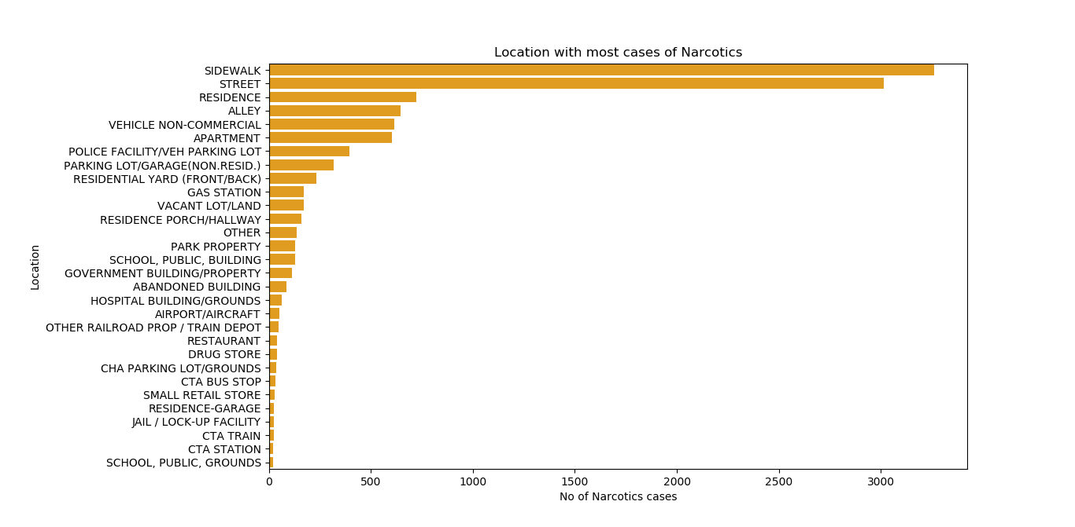

* Sidewalk and streets record the highest number of such crimes.
* General public should be made aware of the consequences of consumption of such particles.

1. Narcotics crimes in according to the day of the week:

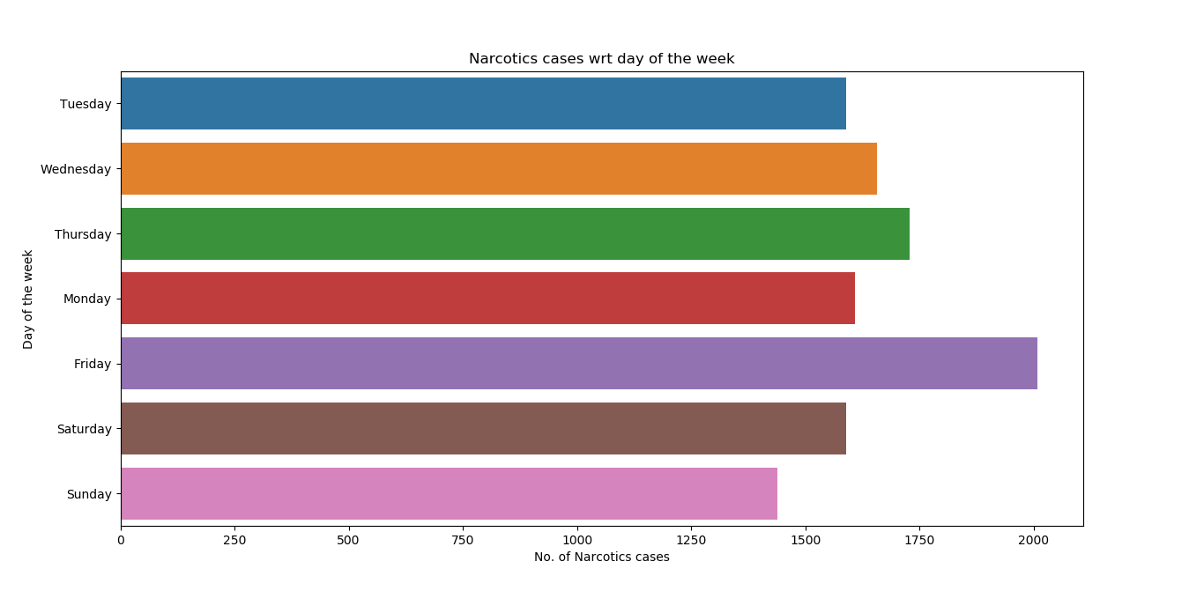

* Friday records the highest number of these crimes.
* This may be because of the beginning of weekend and people may wish to get lively and high with consumption of narcotic substances.

1. Narcotic crimes according to time of the day:

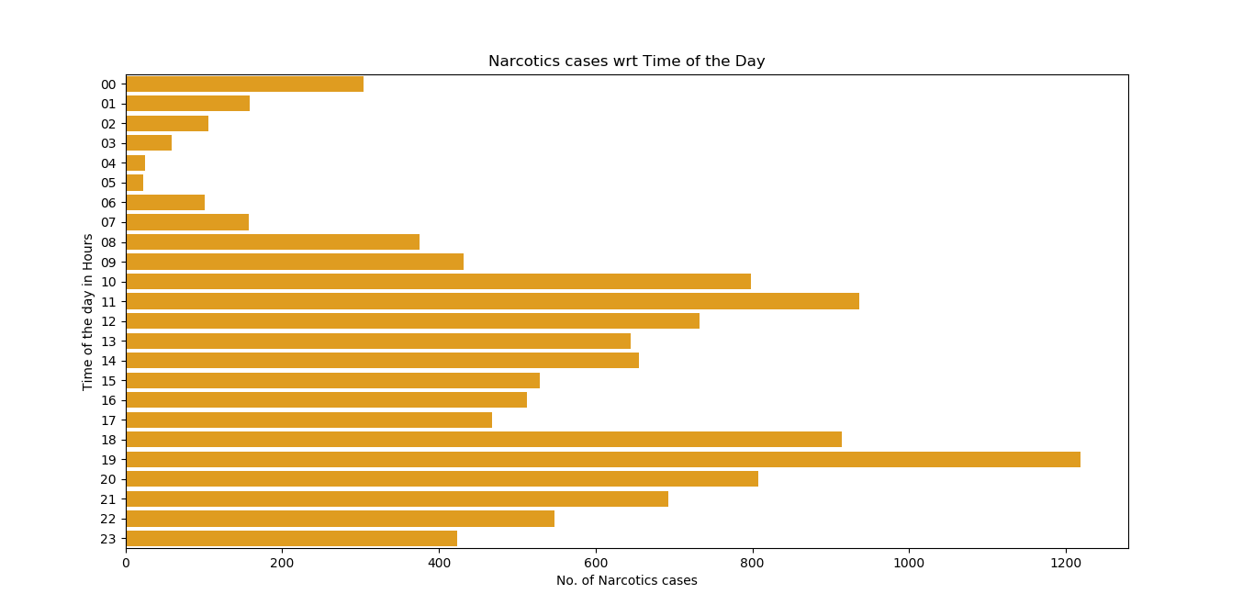

* Late evenings record the highest number of cases, paired with Friday as the day recording highest number of such crimes.
* This confirms our assumption that it is mainly used during the arrival of weekend.

**HOMICIDE**

1. Location of homicide:

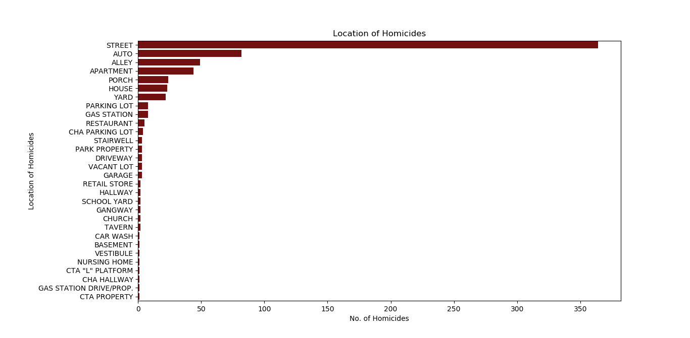

* Streets remain the primary location of crime including homicide.
* The reason can be accidents, scuffles leading to death.
* Public should be made aware of consequences arising due to reckless behavior.

**PROSTITUTION**

1. Prostitution location:

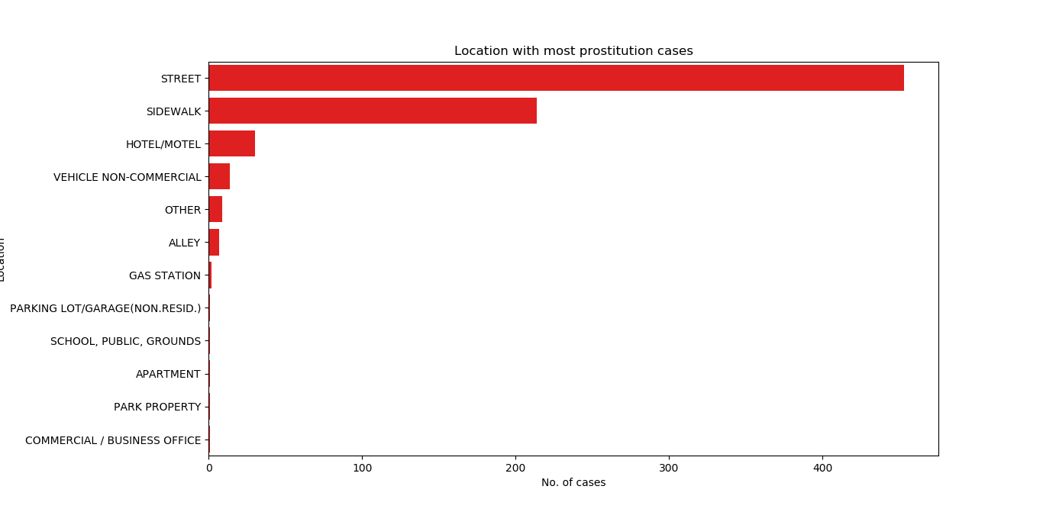

* Isolated streets are the places which lead to rise in prostitution.

1. Blocks with most cases of prostitution:

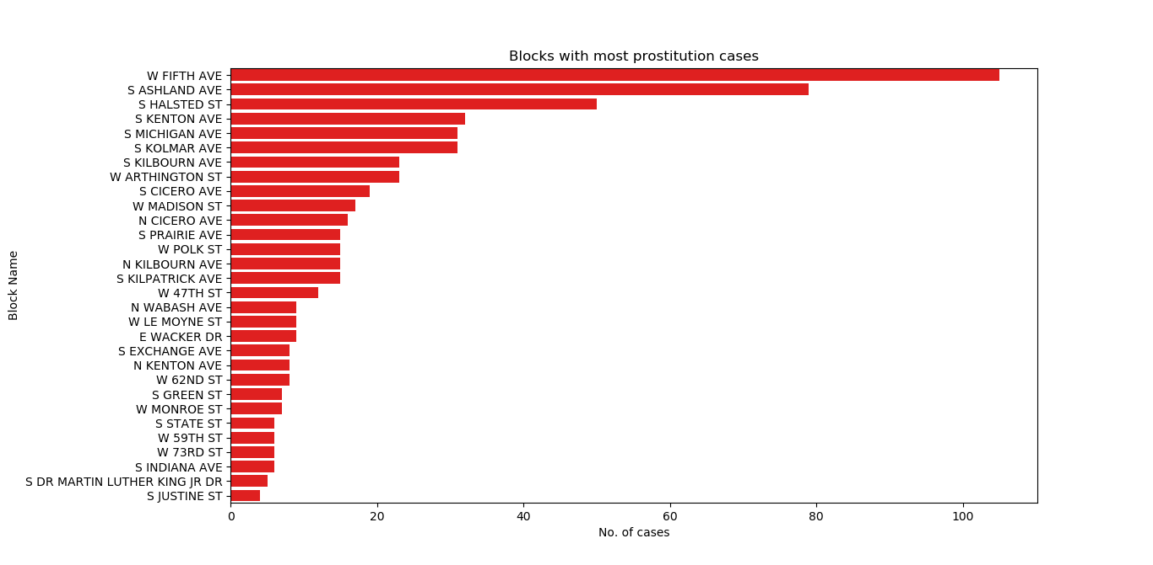

* The usually empty streets of West Fifth Avenue and South Ashland Avenue serve as a perfect destination for flesh trade.
* Patrolling of such localities can drastically reduce the cases of prostitution.

1. Arrests in case of Prostitution:

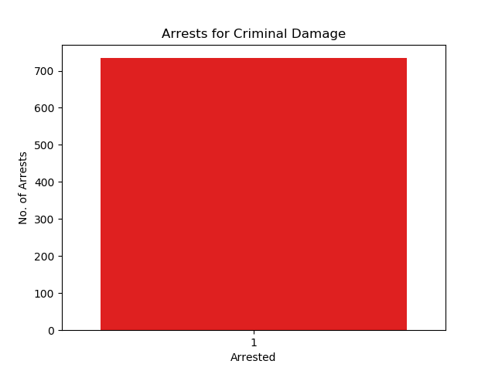

* A record achievement by Chicago law enforcement is 100% arrest rate with respect to crimes related to prostitution.
* However, it is best to prevent prostitution instead of letting criminals let off the hook.

**OTHER OFFENCES**

1. List of other offences:

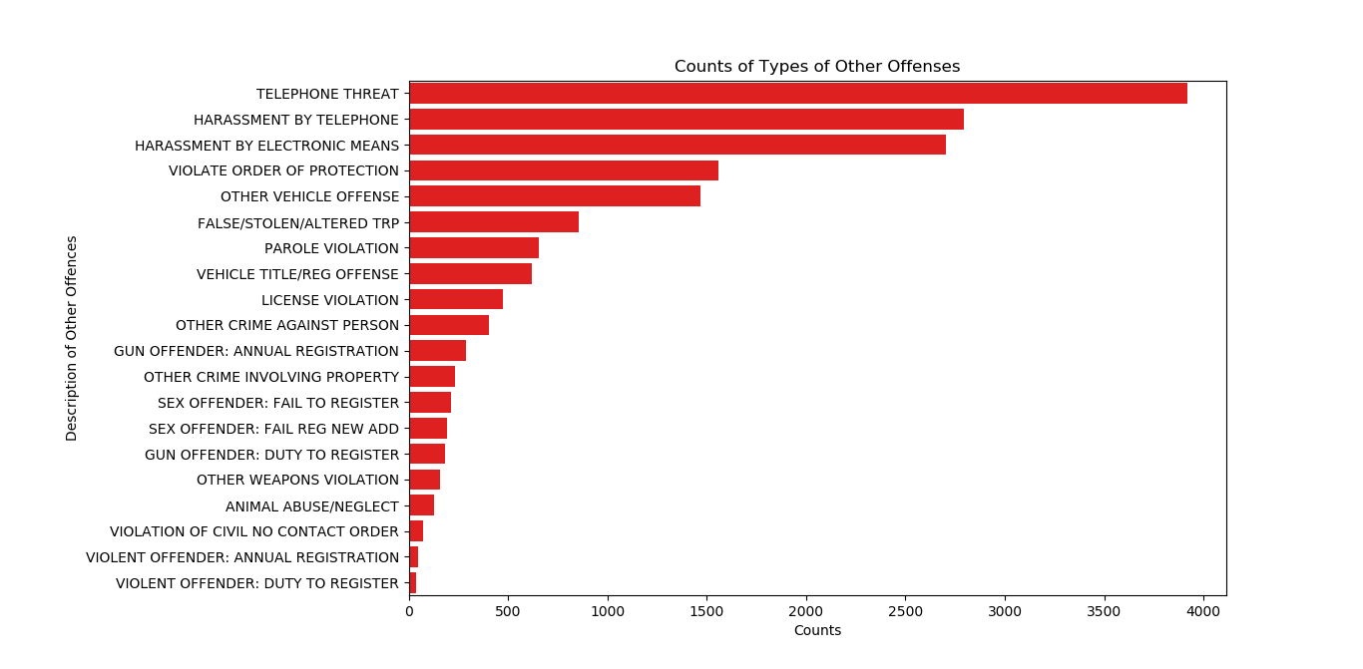

* Threats via telephone and electronic means top the list of such crimes.